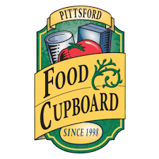

My name is:

I am collecting food from my friends and neighbors to donate to the Pittsford Food Cupboard. If you would like to help, just put the items you want to give in a bag and leave it in a visible location for me to collect on:

DATE: ________________________________
TIME: ________________________________

If you have any questions, my phone number is:

PFC is a client-choice emergency food source supported largely by the Pittsford Community. The Pittsford Food Cupboard was established in 1998 to serve the needs of people in the following zip codes:
14534, 14445, 14607, 14620, 14610, 14618, 14472, 14506, and some of 14625 (those who are part of Pittsford School District)

I hope you can help donate one or more items to this drive!
THE MOST NEEDED ITEMS ARE:
- STRAWBERRY JAM
- CHICKEN OR VEG BROTH
- MEALS IN A CAN (beefaroni, ravioli etc)
- PROTEIN IN A CAN (CLAMS, ANCHOVIES, HAM, SAUSAGE)
- CANNED PINEAPPLE, MUSHROOMS, OLIVES, SPINACH, ARTICHOKES, BEETS
- BODY LOTION, BODY WASH
- RAZORS, SHAVING CREAM
- HAND SANITIZER
- DISH SOAP, LAUNDRY SOAP

To make a secure, online donation or to find out more about the PFC, visit our website:
pittsfordfoodcupboard.net
or connect with us on
Facebook or Twitter
THANK YOU FOR YOUR SUPPORT!

